One Arm Bent Over Row
The One Arm Bent Over Row exercise is great for people who suffer from upper back, neck and shoulder pain. People who sit in desk jobs for long periods of time can experience burning pain in the upper back due to improper posture and weak muscles. This is also a good strengthening exercise for commuters, cyclists, and for people with forward head posture.

Targeted Muscles: Upper back, shoulders, biceps, abs.

Action Desired: Strengthen upper back muscles and shoulders.

Steps:
1) Stand with one leg forward, knee slightly bent, place other leg back as if you were in a lunge position. Bend your torso at about a 45 degree angle. Place the forward hand on the knee for support and let the other arm hang straight down (Fig.1).

2) At a controlled pace, bend the hanging arm back so that your elbow is aligned with your back (Fig.2), do a slight pause, then bring back to starting position. Do about 10-15 reps then switch to other side and repeat movement.

Note: Make sure to keep your back straight and head looking straight.

Modified Version: Add a dumbbell for weight resistance.

Repetitions: 10-15 reps twice a day on each side.

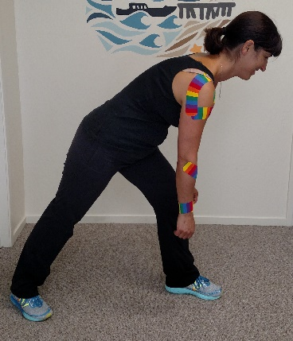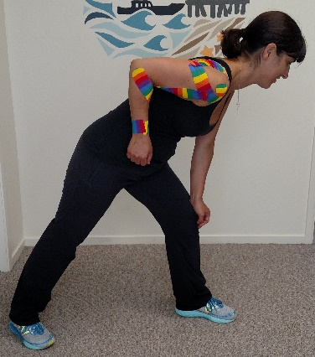
1
2

* If these movements cause any pain or discomfort, please consult with your chiropractor.

