Reverse Fly
The Reverse Fly exercise is great for people who suffer from upper back and shoulder pain. People who sit in desk jobs for long periods of time can experience burning pain in the upper back due to improper posture and weak muscles. This is also a good strengthening exercise for commuters, cyclists, and for people with forward head posture.

Targeted Muscles: Upper back, shoulders, neck.

Desired Action: Strengthening of upper back and shoulders, improving movement and function as well as posture.

Steps:
1) Stand with your feet shoulder width apart. Bend your knees slightly and bring your torso forward by bending at the waist at about a 45 degree angle (Fig.1). Make sure to keep your head up and your eyes facing forward. Each elbow should be slightly bent, palms facing each other (Fig.2).

2) Moving only at the shoulders, raise your arms in a semi-circular motion out to your sides until your arms are parallel to the floor (Fig. 3). Keep the slight bend in your elbows throughout the movement. Squeeze your shoulder blades at the height of the movement (Fig.4) and then slowly lower the arms to the starting position.

Note: Make sure when raising your arms you do not go higher than shoulder height to avoid injury and to work the proper muscles.

Modified Exercise: Add dumbbells or a resistance band to intensify the movement.

Repetitions: Perform 10-15 reps, two times per day.

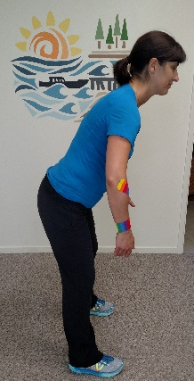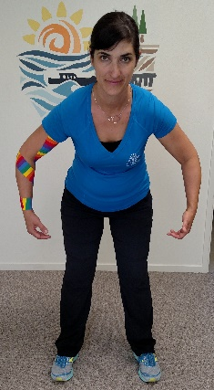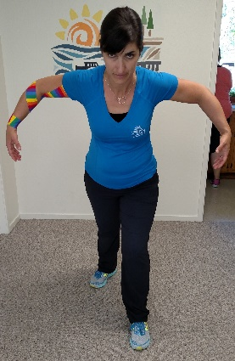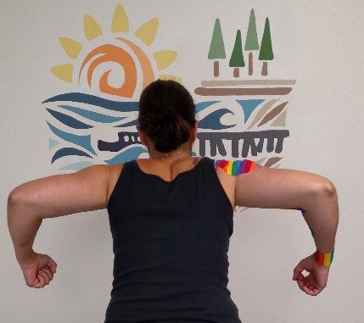
1
4
2
3
* If these movements cause any pain or discomfort, please consult with your chiropractor.

